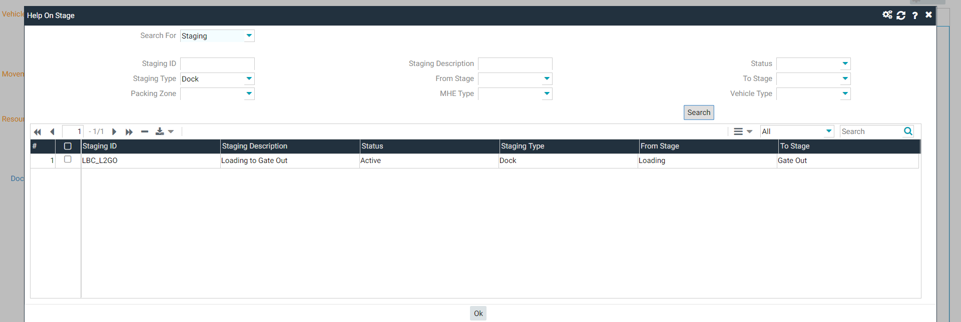
Tried to select stage :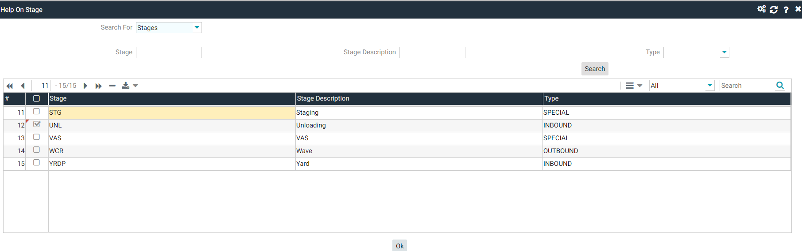
But its is not shown in the UI.
While attempting to create unload Operation :
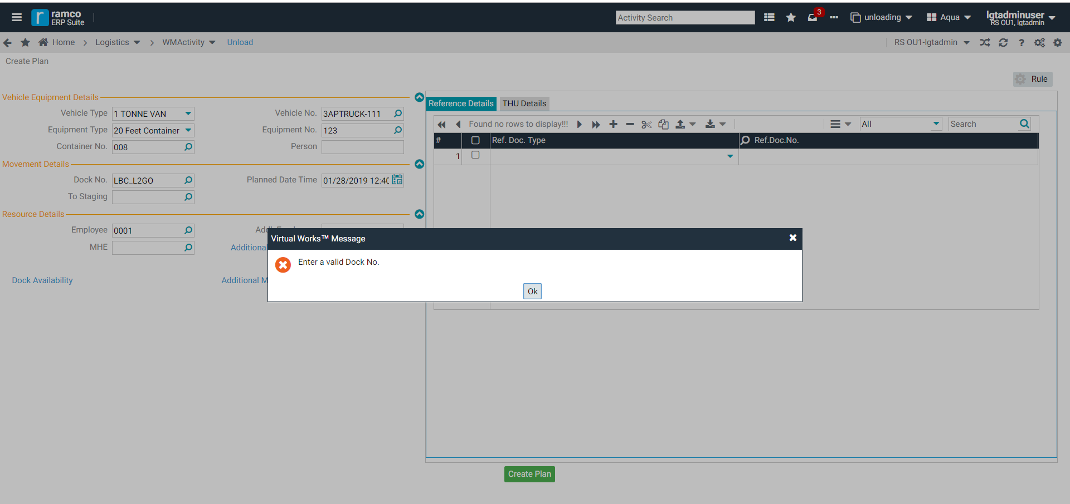
I can’t able to create Unloading Operation with test location of 10000.

Shift in Location :
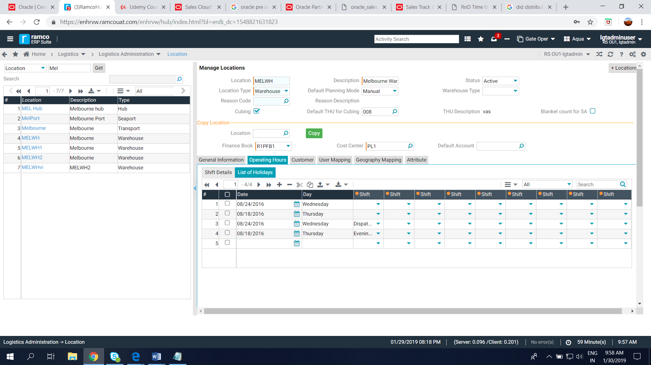
Gate
Shift is not Updating in location screen , So, it cannot able to change as default user..
Gate Operation :
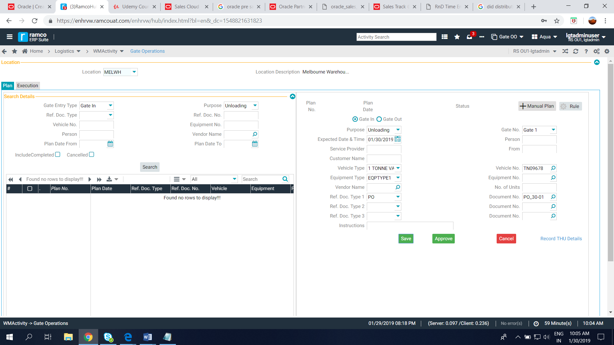

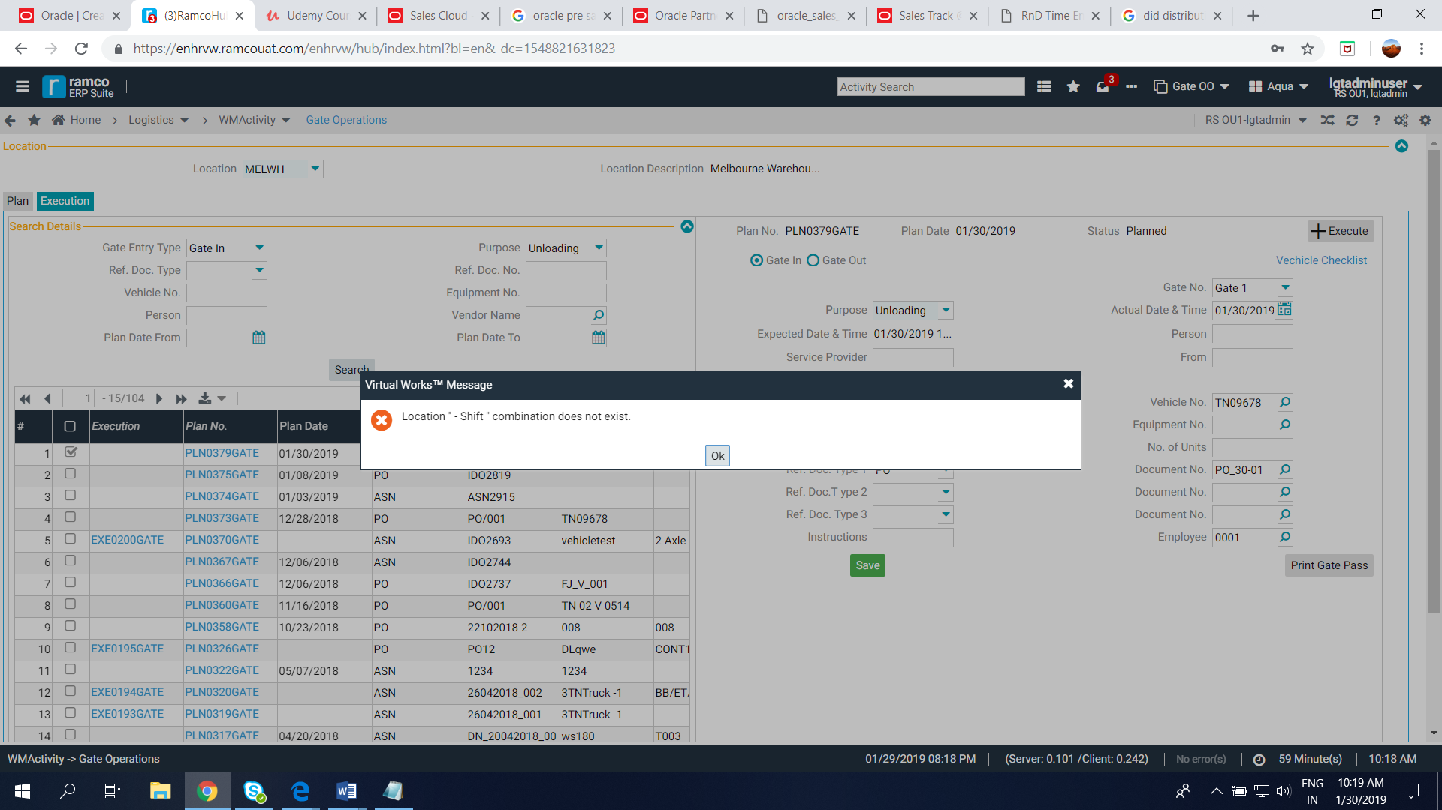
We can’t able to change the Shift in location screen , Because of that we can,t able to Excute Plan .
How to map Gate to Location ??
There is no gate mapped with location 10000.

Putaway :
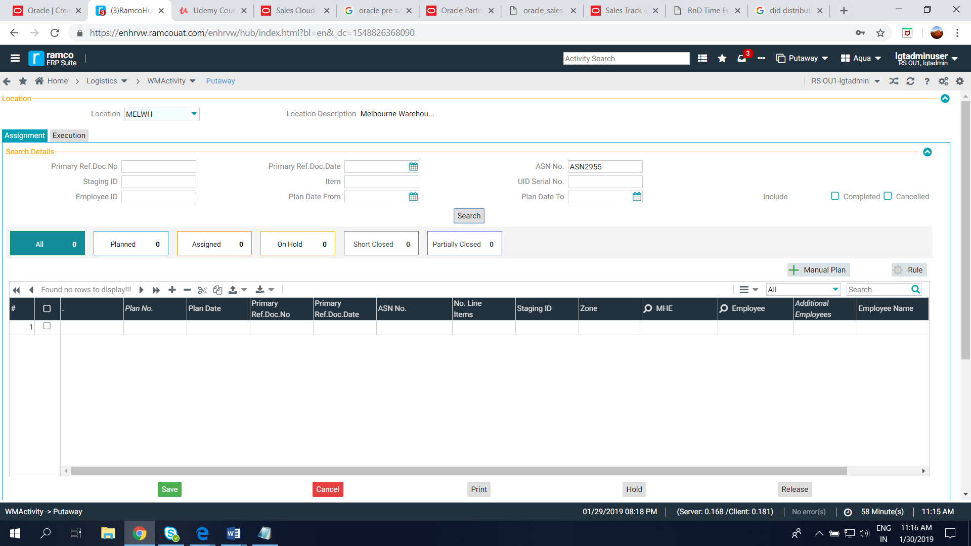
PO is not shown in the Putaway screen…
How to assign a item to multiple customer ???
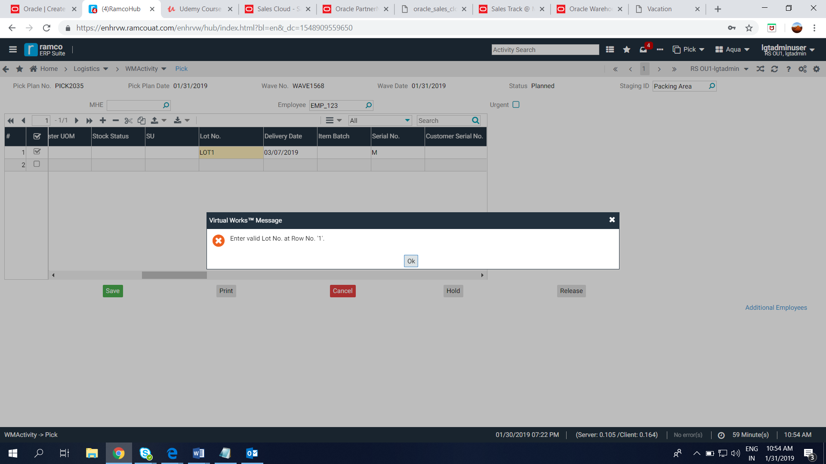
Can’t able to create pick task ..

