

Requirement Specification Document

For

Tender request specifying multiple point delivery in a single trip.

ProConnect Supply Chain Solutions

Document Name | PCS_TMS_004
Version No | 1.0
Date | 5th Dec 2017
Status | Draft

Modification History
Version No. | Author | Date | Pages/ Sections Affected | Remarks
1.0 | Tilak | 5th Dec 2017 |  | Initial Draft

Distribution List
Version No. | Name
1.0 | Giridharan M, Tillak, Srini, Ashish

Sign off
Company | Name | Date | Signature
TMS Consultants | Tilak / Giri
Solution Architect
Mentor
Project Manager

Contents
Change References 4
Booking Request Functionality 5
Requirement Details 5
Details of Business Functionality 5
Assumptions 5
Document Flow 5
Document Status 5
Functionality Details 5
Component and Activity Details 5
Specify the details of affected component & activity 5
User Interface Details 6
SPECIFICATIONS 6

Change References
Sl. # | Requirement/Change ID | Change Details

Tendering Request – specify multipoint delivery as a data capture

Requirement Details

Details of Business Functionality

- While Tendering request to vendors, proconnect wants to intimate vendor (s) that multiple points may be involved for delivery in between the ship from and ship to points
- This will help them in notifying as well as maintaining data of vendors who can handle this requirement

Assumptions
- Trip plan is generated for selected BRs for tendering
- Vendors given access to vendor portal for responses

Document Flow

Document Status
- If Applicable

Functionality Details

Component and Activity Details

Specify the details of affected component & activity
Sl. # | Component Name | Change Type | Activity Name | Change Type (Existing / New)
 | Logistics | New | Detailed Booking Request  Navigation:  Logistics Transportation Management Activity planningtendering request | New

User Interface Details

Affected user Interfaces
Sl. # | Component/ Function | Activity Name | User Interface Name | Change Type (Existing / New)
 | Logistics Transportation Management | Booking Request | Booking Request PlanningTendering request | New

Specifications

Proposed solution

- In the header , we will have 2 controls – Check Box and Text field
- We will have a check box to specify if there is multipoint delivery involved
- When this box is checked, text field adjacent should get enabled for editing for the user to specify information the multipoint deliveries in the header of Tendering request screen
- When this box is not checked, the text field should be disabled for editing
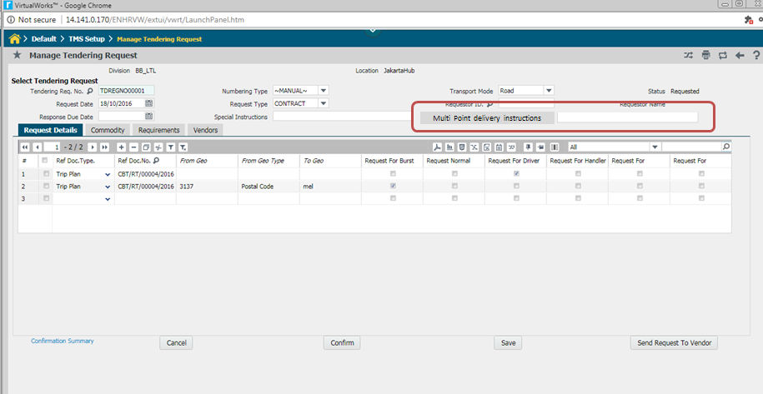

- The same field has to appear in the vendor response screen (and vendor portal) so that vendor’s comments against the multi-point delivery requirement can be captured

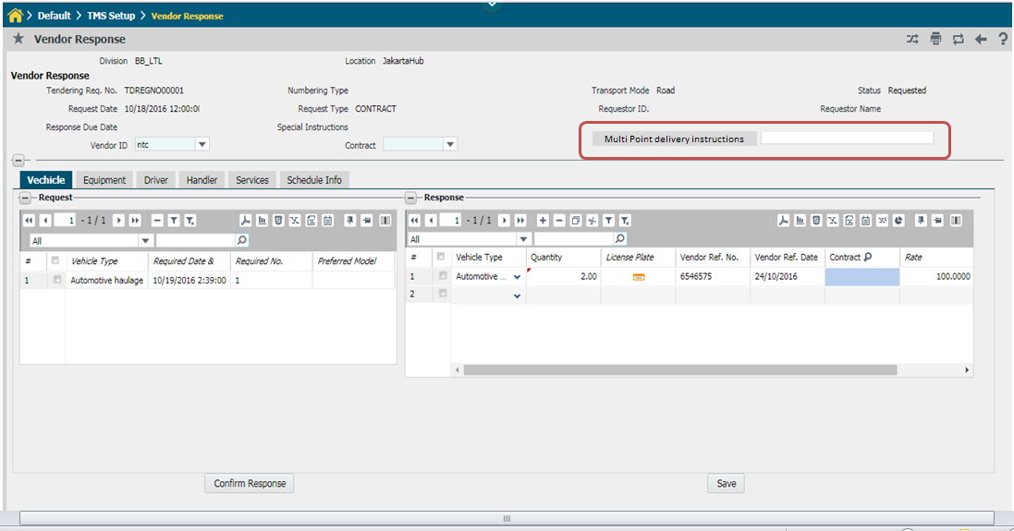

If the checkbox in Tender response screen is unchecked, this field would be display only (with no data)
When checkbox is enabled and data is entered, in vendor response this field will be editable and should be defaulted with the instructions originally entered during tendering request

- UI details

Key Header Details (if applicable)
Sl. # | Field | Field Type | Details | Remarks

Process Logic

Task | Business Rule Description

